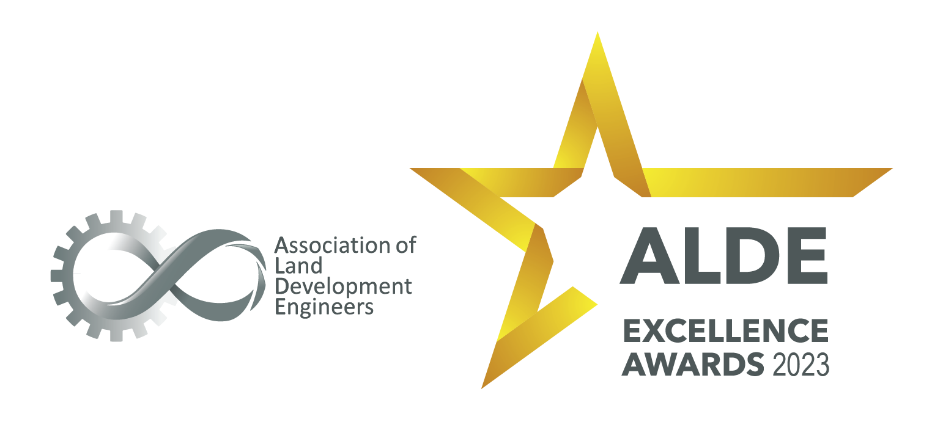

Entry form

Best Medium Sized Consultancy of the Year

https://www.alde.com.au/

Best Medium Sized Consultancy of the Year

Description:
This award recognises a Medium sized (20-50 employees, including corporate and admin roles) Consultant who comprehensively supports its engineers, and who proactively promotes diversity and equality, creating an inclusive profession.

Requirements:
- This is open to consultants in the land development industry with a current ALDE Membership (General or Sustaining)

Entry Instructions:

Please complete the form by providing responses in the table below. Images and descriptions can be inserted into this document in the last field.

Ensure responses consider the criteria, word limit and are concise.

Once complete, the entry should be emailed to awards@alde.com.au
A confirmation of receipt will be sent.

Application:
Name of Consultant:
What are the contact details of the person authorised to liaise with ALDE in respect to this entry:
Name:
Email address:
Telephone:
Declaration:
I confirm that I am duly authorised by the Consultant named above to submit this entry.

Please include signature, name and date.

Description of Consultant (location, target market, number of employees, etc ). (Max 300 words):

Executive Summary of entry (Max 300 words):

If successful in winning an award or receiving a commendation, who will receive the award at the ceremony:

Criteria # 1 – Describe and provide examples of policies and actions which foster diversity, equality, and inclusion in the industry. (Max 300 words):

Criteria # 2 – Describe programs or processes that achieve improvements in educational and technical standards and skills. Provide examples. (Max 300 words):

Criteria # 3 – Describe how your business has advocated for and fostered the standing of consultancies within all forms of government and the community generally (Max 300 words):

Criteria # 4 – Describe actions of your business which demonstrate how ethical standards have been upheld (Max 300 words):

Criteria # 5 - Describe your Consultancy’s commitment to the ongoing health and safety of your team and workplace. (Max 300 words)

Criteria # 6 – Describe the obstacles and difficulties faced as a medium sized Consultant and explain how your business overcomes these. (Max 300 words)

Criteria # 7 - List 3 special project examples your business is proud of, including number of lots / estate major works, etc. Explain how the projects stand out (Max 700 words)

Images: Please include your business logo and any other images which support your entry. (High quality image in jpeg format)

