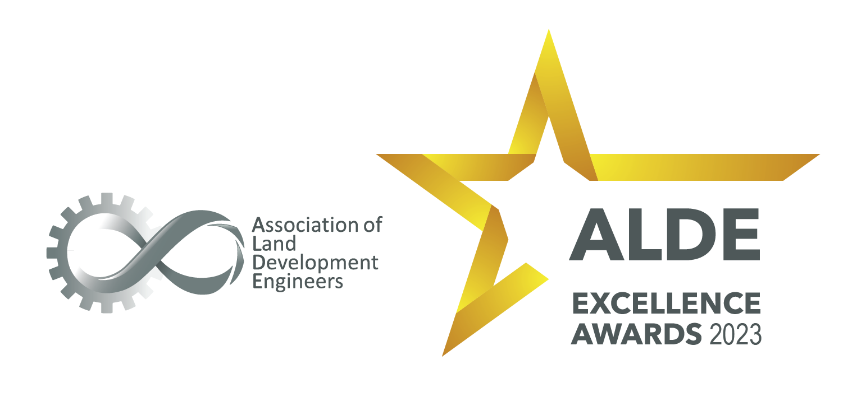

Entry form

Engineering Excellence & Innovation

https://www.alde.com.au/

Engineering Excellence & Innovation

Description:
- This award recognises excellence and innovation. This can be achieved through many different routes – for example, achieving better outcomes in a different way to a standard process, inventing something completely new or applying existing technology or process to solve a problem; this creating an optimised product.

Requirements:
- This is open to the whole of the land development industry with a current ALDE Membership.

Entry Instructions:

Please complete the form by providing responses in the table below. Images and descriptions can be inserted into this document in the last field.

Ensure responses consider the criteria, word limit and are concise.

Once complete, the entry should be emailed to awards@alde.com.au
A confirmation of receipt will be sent.

Application:
Name of Organisation:
What are the contact details of the person authorised to liaise with ALDE in respect to this entry:
Name:
Email address:
Telephone:
Declaration:
I confirm that I am duly authorised by the Organisation named above to submit this entry.

Please include signature, name and date.

Description of Organisation (location, target market, number of employees, etc ). (Max 300 words):

Executive Summary of entry (Max 300 words):

If successful in winning an award or receiving a commendation, who will receive the award at the ceremony:

Criteria # 1 – Describe the project. (This sets up the context of the project and helps judges to compare projects). Describe the timeframe of the project (is it a discrete project or part of a bigger program) relative size, and a brief statement of complexity (multiple stakeholders, unusual constraints). (Max 300 words):

Criteria # 2 – Describe the innovation and why the innovation was required. (Max 300 words):

Criteria # 3 – Describe the impact of the innovation and provide evidence of how the innovation has led to the creation of new process, standards, skills, knowledge, or experience (Max 300 words):

Criteria # 4 – Explain how the innovation improved the commercial viability of the project (capital and/or cost) (Max 300 words):

Criteria # 5 - Contribution to Industry: Describe how the project has had an ongoing impact on the industry or the community, for example realising new technical, social, cultural, environmental and/or economic benefits. (Max 300 words):

Images: Please include your business logo and any other images which support your entry. (High quality image in jpeg format)

