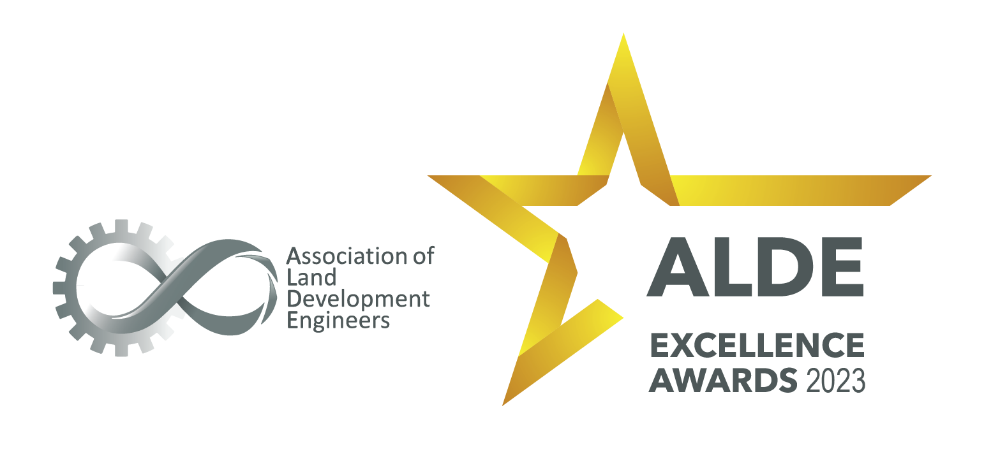

Entry form

Supporting Consultant or Supplier

https://www.alde.com.au/

Supporting Consultant or Supplier

Description:
- This award recognises excellence displayed by a Supporting Consultants (Supporting a General Member / Civil Consultant) or supplier in the land development industry. (Examples of supporting Consultants or Suppliers include geotechnical, structural, telecommunications, electrical, hydraulic consultants, materials or information suppliers)

Requirements:
- This is open to the Sustaining members of ALDE.

Entry Instructions:

Please complete the form by providing responses in the table below. Images and descriptions can be inserted into this document in the last field.

Ensure responses consider the criteria, word limit and are concise.

Once complete, the entry should be emailed to awards@alde.com.au
A confirmation of receipt will be sent.

Application:
Name of Organisation:

What are the contact details of the person authorised to liaise with ALDE in respect to this entry:
Name:
Email address:
Telephone:
Declaration:
I confirm that I am duly authorised by the Organisation named above to submit this entry.

Please include signature, name and date.

Description of Organisation (location, target market, number of employees, etc ). (Max 300 words):

Executive Summary of entry (Max 300 words):

If successful in winning an award or receiving a commendation, who will receive the award at the ceremony:

Criteria # 1 – Describe and provide examples of professional approach to land development projects and how this benefits industry stakeholders. (Max 300 words):

Criteria # 2 – Provide evidence of where Safety, Quality & Environment is embedded in the culture of the business. Provide examples. (Max 300 words):

Criteria # 3 – Provide a description and examples of capability through outstanding project work (Max 300 words):

Criteria # 4 - Describe description and examples of working with consultants and proven ability to communicate and cooperate. (Max 300 words):

Criteria # 5 – Provide examples on how your business has worked with/in the land development industry to achieve better outcomes for community and stakeholders (Max 300 words):

Criteria # 6 - Describe your organisation’s achievement of excellence in delivery of services to the land development industry, including business vitality and culture, business accreditations staff development, community involvement, support for young professionals and professional image. (Max 300 words)

Criteria # 7 - Explain your commitment to ensuring your staff and team are encouraged to continue developing in order to help the company achieve excellence (Max 300 words):

Images: Please include your business logo and any other images which support your entry. (High quality image in jpeg format)

